
Sean Groves
#2303829
Web Programming CIT2011
C. Anuli Wed 10 am

Logo
Firstly, for the logo, I decided on the name ‘Rendezvous’ because it is a simple word which conveys an elegant message of both time and place, which is the whole purpose of the company. I was torn between utilising a simple symbol or a logo that uses both a symbol and a word.

I ultimately decided to use both throughout the project.

Slogan
“Where time meets the sky” – a simple yet effective motto to convey the purpose of the business.

Colour Palette
For my colour palette, I tried to convey a feeling of luxury upon opening the site. I used mainly a dark shade of grey, almost black, along with gold and white as tertiary fillers. I wanted every page to feel expensive because they were costly items.
Audience
The store is not meant to intimidate buyers but to make them feel comfortable making these big decisions, and the process is as smooth and straightforward as it can be. We expect to draw in clients who have the desire to travel in style and/or be a stylish time keeper among their peers. Avid watch collectors and travelling fanatics.

Mission Statement
At Rendezvous, we specialize in offering an exclusive selection of luxury watches and private jets. Our curated collection features timepieces from the world's most prestigious brands, known for their craftsmanship, innovation, and timeless design. Whether you're a seasoned collector or a first-time buyer, our expert team is here to guide you through our offerings and help you find the perfect watch that suits your style and needs.
In addition to our exquisite watch collection, we provide access to a fleet of private jets for those seeking unparalleled travel experiences. Our private jet services cater to discerning clients who value privacy, comfort, and convenience. From short domestic flights to international journeys, we ensure that every aspect of your travel is handled with the utmost care and professionalism. Discover the epitome of luxury with Rendezvous - where time meets the sky.

Wireframes
Home page
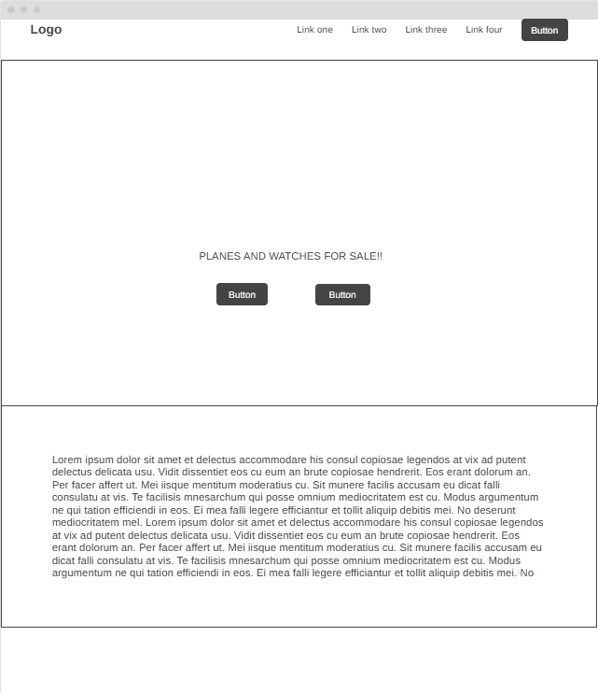
Watch collection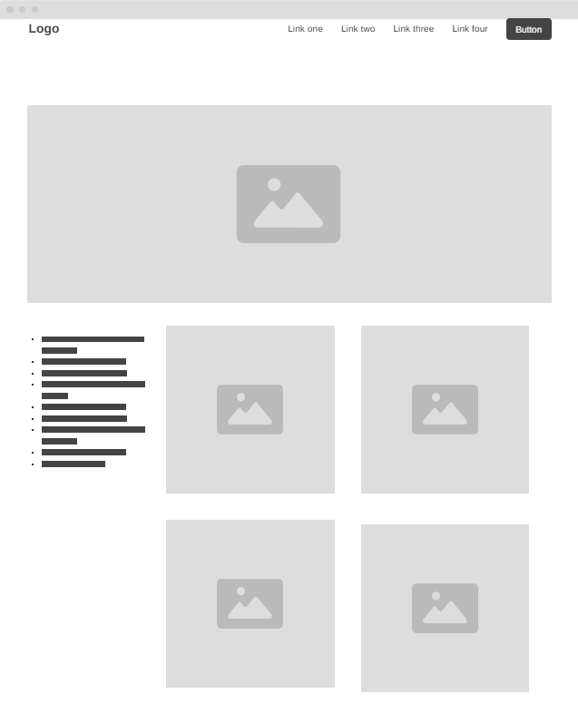

Cart page
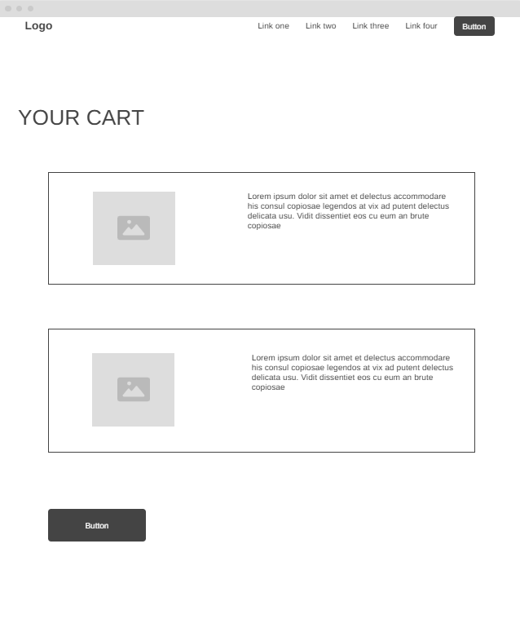

Visit Rendezvous here: https://rendevous.netlify.app/

Sources for all assets;
home page watch - https://i.pinimg.com/736x/c5/0f/9c/c50f9c17e894a1a1c680ad810888ca4d.jpg
home page jet –
https://i.pinimg.com/1200x/f1/e2/23/f1e223a953fad0a35372718e94baf0cf.jpg
watches for sale –
https://www.pinterest.com/5c8de379-867e-46b5-9b2f-00b5a2e4d17c
https://www.pinterest.com/7656fb23-7951-42ca-8324-f30c737945af
https://www.pinterest.com/92d7dcb5-2f39-44a8-a375-ccbd39045527
https://www.pinterest.com/c6e01166-2765-4506-a7c6-8d16e286c043
https://www.pinterest.com/b494046d-ad29-4458-9107-e57c8d39f62f
https://www.pinterest.com/0e17c3c9-6f9a-4443-a615-d6308af69493

